**AWS CLI**

* AWS has command line interface using AWS CLI
* To work with CLI we need IAM Programmatic Access (Secret Access key Id & Secret Access Key)
* AWS CLI is used to automate the aws infra creation & management with the help of shell scripts or powershell
* AWS CLI: <https://docs.aws.amazon.com/cli/latest/reference/>

aws [options] <command> <subcommand> [parameters]

**How to work with cli:** CLI works with id’s

**Exploration-1: Create a VPC (virtual network) in Mumbai**

* Manual steps:  
  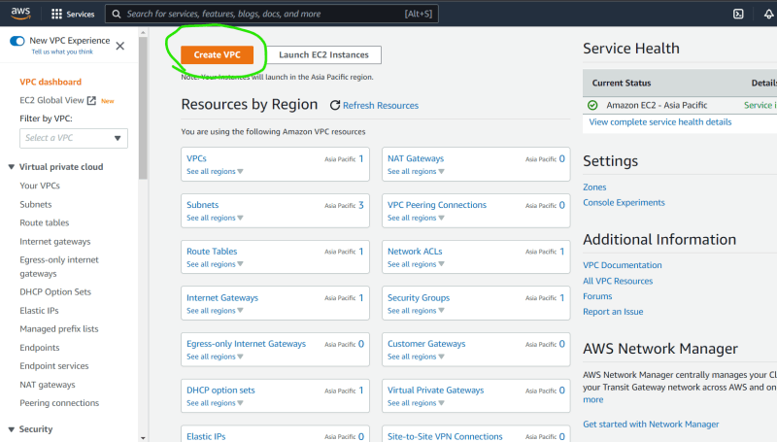  
  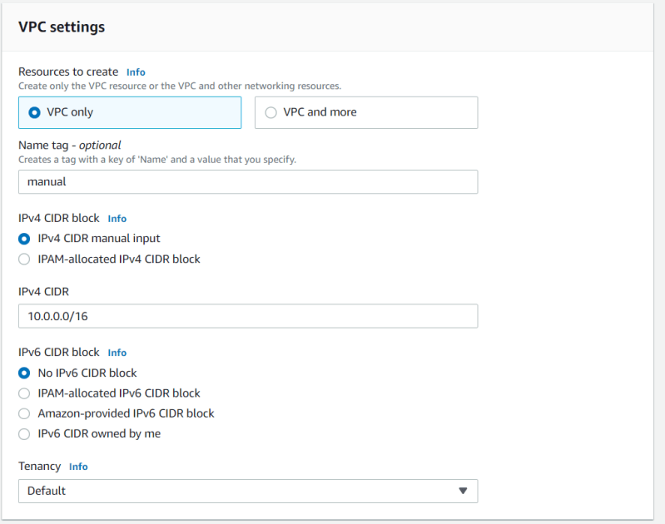  
  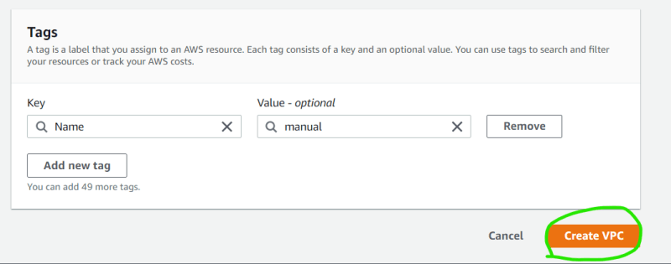

CLI Approach:

Search google with aws vpc cli  
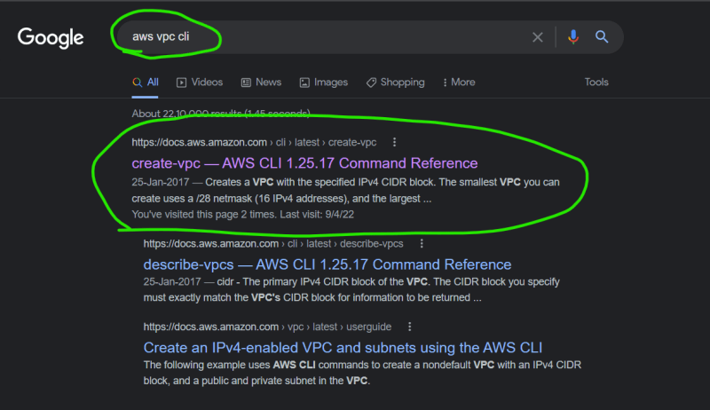

* + Now open the docs  
    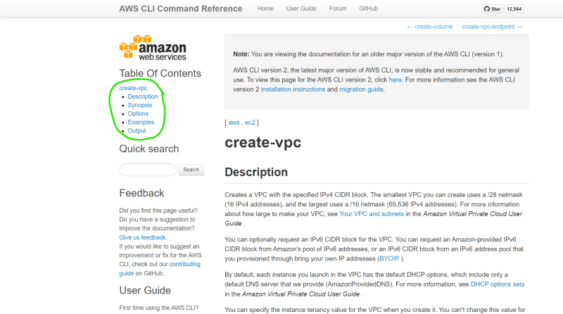  
    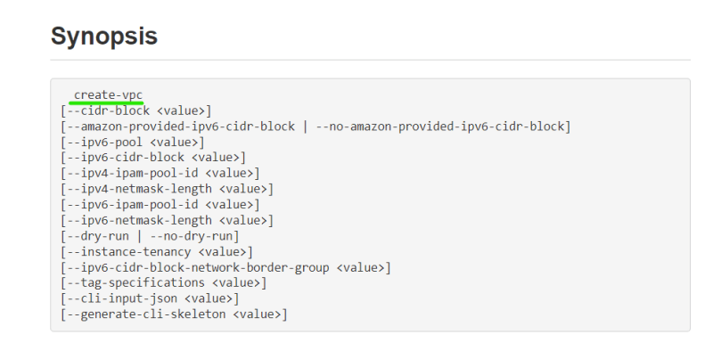
  + To form aws cli aws ec2 create-vpc
* Command:

aws ec2 create-vpc `

--cidr-block "10.0.0.0/16" `

--tag-specifications "ResourceType=vpc,Tags=[{Key=Name,Value=fromcli}]"

### output

{

"Vpc": {

"CidrBlock": "10.0.0.0/16",

"DhcpOptionsId": "dopt-da183fa2",

"State": "pending",

"VpcId": "vpc-0c198c1a8182f440d",

"OwnerId": "678879106782",

"InstanceTenancy": "default",

"Ipv6CidrBlockAssociationSet": [],

"CidrBlockAssociationSet": [

{

"AssociationId": "vpc-cidr-assoc-0ebe69be5e5e4fc1c",

"CidrBlock": "10.0.0.0/16",

"CidrBlockState": {

"State": "associated"

}

}

],

"IsDefault": false,

"Tags": [

{

"Key": "Name",

"Value": "fromcli"

}

]

}

}

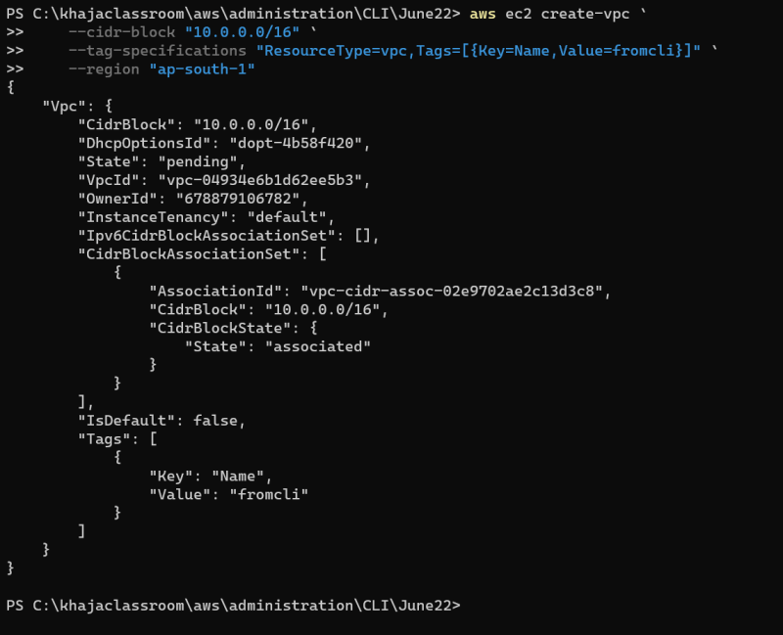  
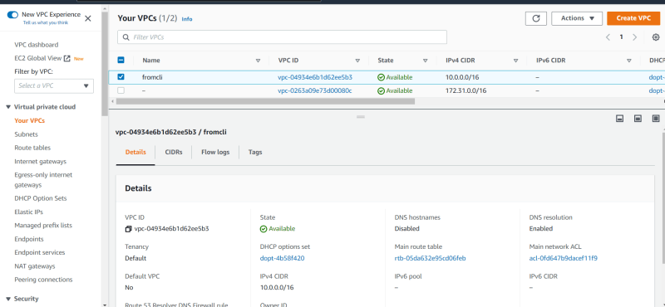  
* Now let’s add one subnet (manual)  
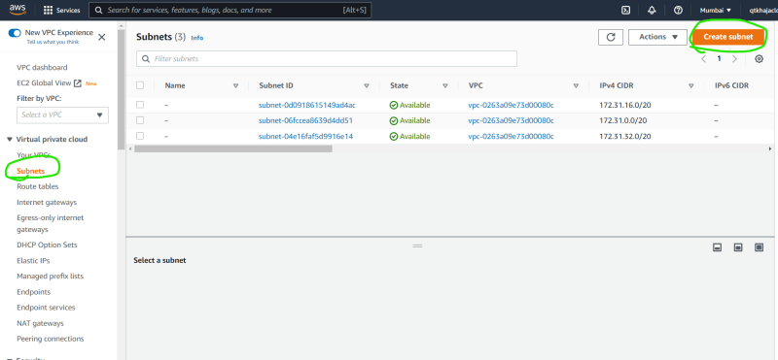  
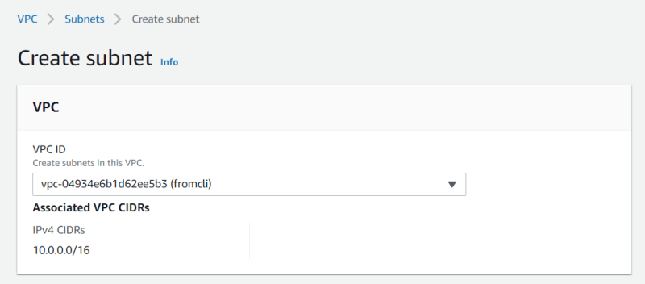  
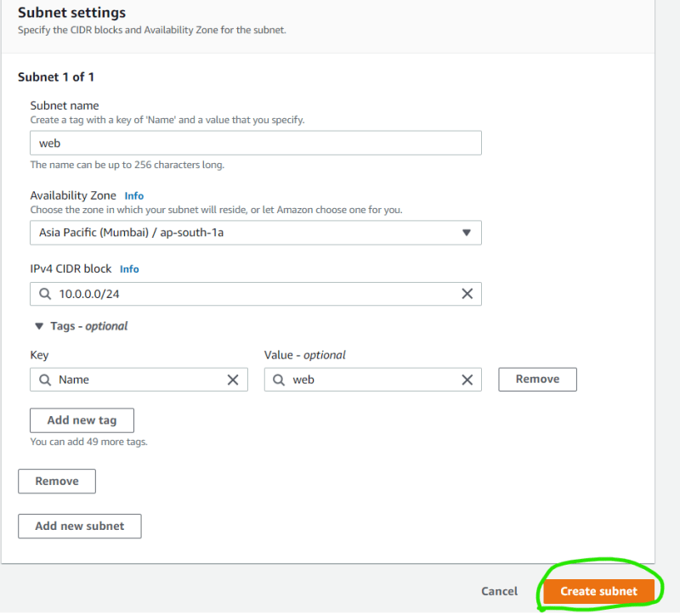  
* From cmd line  
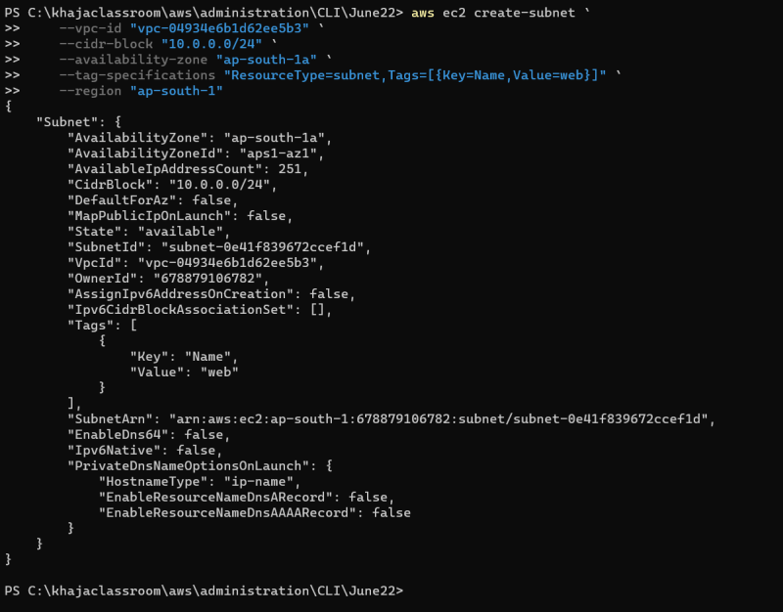  
* Note: Any AWS resource will not have name, rather it will have tags.  
* Exercise: Go through JMES path tutorial [Refer Here](https://jmespath.org/tutorial.html)